Programming 1 (Web-based Programming)

Ms. Eng

MCNDHS

Weekly Summative Assessment

|  |
| --- |
| Name: |
| Period: |

**OPEN NOTEBOOK (ONLY YOUR NOTES PLEASE)**

**Part 1 (Multiple Choice)**

1. What does HTML stand for?
2. Hyper Text Make up Language
3. Hyper Text Mark up Language
4. Hyper Total Marker Linguistics
5. Hi There Meet Lisa
6. Which of the following is a correct naming protocol for a repository folder?
7. MywebSite
8. mywebsite
9. ~*MyWebsite*~
10. Mywebsite<333
11. What are not allowed for naming folders?
12. Spaces, symbols, and DDR
13. Spaces, symbols, and uppercase letters
14. Numbers, repeating words
15. Red, Orange, White, Yellow
16. What is this: index.html
17. A list of your files.
18. A pointer file.
19. A point tag.
20. The homepage.
21. What is this: <!DOCTYPE html>?
22. The element that asks permission to open a file on a webserver.
23. A network key.
24. Informs the browser that the file is a webpage.
25. The process of going back in time.
26. Which part is html <i>this is code</i>
27. this is code
28. <i>
29. </i>
30. <i></i>
31. How do you change the name of a webpage?
32. <body></body>
33. <html></html>
34. <!DOCTYPE html>
35. <head></head>.
36. What is the role of an opening tag?
37. It begins a function of HTML onto text.
38. It opens your files.
39. Saving a webpage file.
40. You are it.
41. What is the role of a closing tag?
42. To delete a file.
43. It stops the HTML function on text.
44. To close a tab.
45. Microsoft word 2000.
46. Which of the following is the correct formatting of a tag?
47. </i> </i>
48. <i></i>
49. (i)(/i)
50. (/i)(/i)
51. What is a repository?
52. Your project folder.
53. An access keylock.
54. A collection of isolated HTML files.
55. A selection of files for your website.

Part 2: Use the following code to answer the problems:

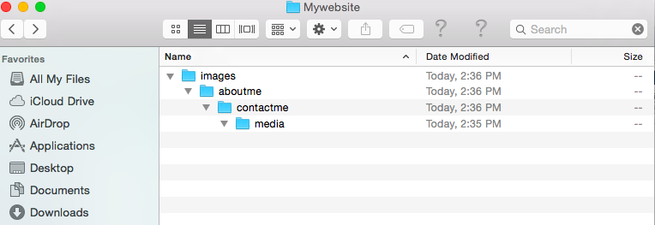

Scenario:

You have your repository folder and you are trying to access your media subfolder. When you tried to type in your link:

http://www.mywebsite.com/media

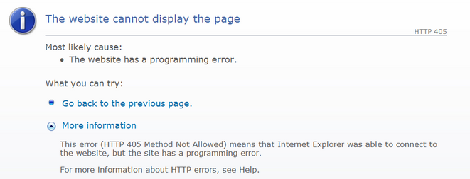

This shows up.

Question 1:

Describe the issue:

Question 2:

What is the solution to this issue?